PROGRAM 2: 8-PUZZLE PROBLEM
Aim
To write a Python program to solve the 8-Puzzle problem.

Objective
To arrange the tiles in the correct order by moving the blank space.

Algorithm
- Define the initial state and goal state.
- Find the blank space.
- Move the blank tile to a valid position.
- Repeat until the goal state is reached.
- Display the solution.

Source Code
from collections import deque
start = (1, 2, 3, 4, 0, 6, 7, 5, 8)
goal = (1, 2, 3, 4, 5, 6, 7, 8, 0)
moves = {
0:[1,3], 1:[0,2,4], 2:[1,5],
3:[0,4,6], 4:[1,3,5,7], 5:[2,4,8],
6:[3,7], 7:[4,6,8], 8:[5,7]
}
queue = deque([(start, [])])
visited = set()
while queue:
state, path = queue.popleft()
if state == goal:
print("Solved!")
print("Moves:", len(path))
break
if state in visited:
continue
visited.add(state)
blank = state.index(0)
for move in moves[blank]:
new = list(state)
new[blank], new[move] = new[move], new[blank]
queue.append((tuple(new), path + [tuple(new)]))

Flowchart
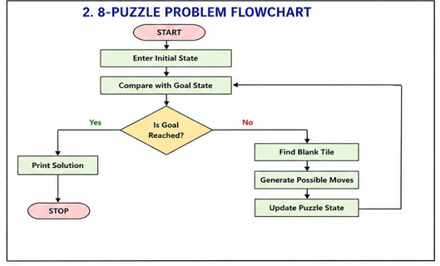
Output
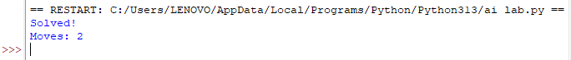
Result
Thus, the Python program to solve the 8-Puzzle problem was executed successfully.

